**AI-Integrated Soil Testing and Fertilizer Recommendation System using IoT and Spectral Analysis**

Soil health is critical for sustainable agriculture. Traditional soil testing methods are slow, expensive, and inaccessible to many farmers. This project proposes the development of an **automated IoT-based soil testing system**, integrated with **multispectral sensors** and **machine learning (ML) algorithms**, to provide **real-time nutrient analysis** (NPK, pH, organic matter) and **crop-specific fertilizer recommendations**.

**Problem Statement**

Conventional soil testing methods are time-consuming, expensive, and often unable to deliver real-time, site-specific data necessary for optimal fertilizer management. This leads to inefficient fertilizer use, resulting in economic losses for farmers and significant environmental degradation due to nutrient runoff and emissions. Existing approaches are labor-intensive and struggle to account for spatial variability across agricultural fields. An AI-integrated system leveraging IoT sensors and spectral analysis can provide immediate, precise soil diagnostics and fertilizer recommendations, enhancing crop yields, promoting sustainability, and reducing operational costs. Designed for universal adaptability, the system ensures reliable performance across diverse soils, climates, and cropping systems.

**Objectives**

* Rapid testing of soil nutrients N, P, K, pH, organic matter, Ca, Mg, Fe, Zn.
* Use **AS7341 multispectral sensor (11 band**) for colorimetric chemical analysis.
* Integrate a **camera-based soil type classifier** (texture, colour).
* Apply **Machine Learning models** to recommend fertilizers based on soil results and selected crops.
* Enable **IoT-based remote monitoring and cloud data logging**.
* Build a **touchscreen-based user interface** on a **Raspberry Pi 4** for easy operation.
* Automate **sample shaking**, **reagent dispensing**, and **light-isolated sensing**.

**System Components**

| **Component** | **Details** |
| --- | --- |
| Microcontroller | Raspberry Pi 4 4GB |
| Multispectral Sensor | Adafruit AS7341 Breakout Board (11 bands) |
| Touch Screen | 5inch capacitive touch display |
| pH Sensor | Gravity Analog pH Sensor (DFRobot) |
| GPS | NEO-M8N GPS Module with Ceramic Active Antenna |
| Organic Matter Estimation | Colorimetric + Spectral Analysis |
| Camera Module | Raspberry Pi Camera V2 8 MP |
| Reagent Dispensing | Stepper motors + Kamoer 6V 0.35A 10.5ml/min silicone tube liquid pump |
| Sample Shaker | Mini DC motor/stepper-based shaking tray |
| Light Box | Custom 3D-printed, light-isolated chamber |
| Power Supply | 5V/3A + 12V Stepper supply |
| Software Platform | Python, TensorFlow Lite, Arduino Cloud/Firebase |
| ADC (analog to digital converter) | ADS1115 16-Bit ADC- 4 Channel with Programmable Gain Amplifier |

**Working Principle**

1. **Soil Sampling**: Soil samples are prepared and reagents are automatically added into vials.
2. **Spectral Analysis**: Colour changes are detected by the AS7341 sensor inside a light-proof box.
3. **Camera Soil Typing**: A camera captures soil texture/colour to assist classification.
4. **Sensor Data Collection**: pH, read real-time N, P, K, pH, organic matter, Ca, Mg, Fe, Zn values.
5. **ML Processing**: An ML model predicts recommended fertilizer types and quantities based on sensor values and crop type.
6. **IoT Upload**: Results are displayed on-screen and optionally sent to a cloud server.
7. **Fertilizer Recommendation**: Suggested fertilizers are displayed along with dosage.

**Innovations**

* **Simultaneous Multinutrient Testing** using spectral and chemical reactions.
* **Automated Vial Handling** (shaking + dispensing + reading).
* **ML-driven Crop-specific Fertilizer Advice**, personalized per soil reading.
* **Affordable, Portable Soil Lab** for farmers and AgriTech companies.

**Expected Outcomes**

* Reduce soil testing turnaround time from days/weeks to minutes.
* Increase fertilizer efficiency by recommending precise nutrient application.
* Empower farmers with accessible, affordable soil health monitoring.
* scalable platform for micronutrient detection (Ca, Mg, Fe, N, P, K, OM).

**Budget (₹20,000)**

| **Item** | **Cost Estimate (INR)** |
| --- | --- |
| Raspberry Pi 4 | 5,700 |
| AS7262 Multispectral Sensor | 2,500 |
| Touch Screen | 2,500 |
| Soil pH | 1,500 |
| Stepper Motors & Drivers | 1000 |
| Reagent materials (chemicals, vials) | 2000 |
| Miscellaneous (3D printing, wires, casing) | 600 |
| ADC | 400 |
| RSpi 5MP Camera | 350 |
| GPS | 800 |
| Cloud subscription | 500 |

**Prototype model**

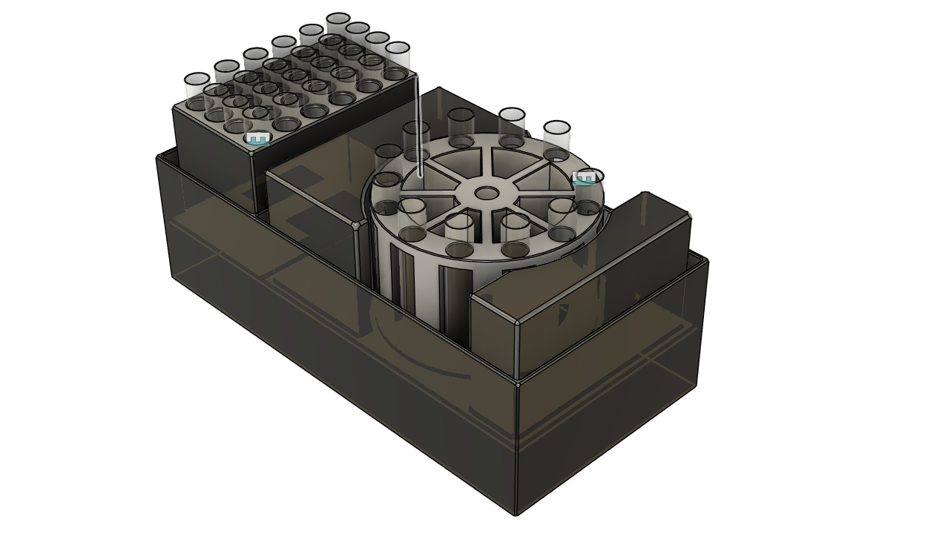

**Light Box with sensor and vial holder**

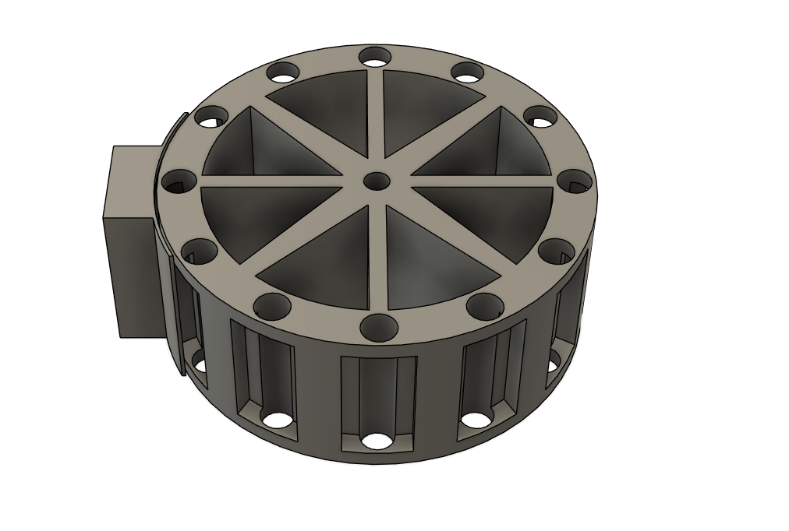

**Process**

**Market Potential & Scalability**

* 145+ million farm holdings in India: vast addressable market.
* Targets:
  + Individual farmers
  + FPOs and Agri-input shops (service model)
  + KVK centres (district hubs)
* Easily scalable with software updates for other nutrients (pH, EC, micronutrients).

**Future upgrade**

* Predict soil amendments beyond fertilizers (gypsum, lime).
* Crop yield prediction module based on soil and weather data.
* Mobile App interface for farmer usage.
* Monitoring vegetation index of the soil sample area using GPS and satellite imaging technique for accessing plants health, Disease